**Library Management System Documentation**

**Introduction**

The Library Management System is a web application designed to automate and streamline the operations of a library. It helps manage books, patrons, borrowing, returns, and other library-related tasks. This system aims to improve efficiency, reduce manual work, and enhance the overall experience for both librarians and library users.

**Spring Framework and Spring Boot**

**Spring Framework**

The Spring Framework is a comprehensive, modular application framework for Java that provides infrastructure support for developing robust Java applications. It offers features like Inversion of Control (IoC), Dependency Injection (DI), and Aspect-Oriented Programming (AOP).

**Spring Boot**

Spring Boot is an extension of the Spring Framework that simplifies the process of building production-ready applications. It provides:

1. Auto-configuration: Automatically configures your application based on the dependencies you've added.
2. Standalone: Creates stand-alone Spring applications that can be run directly.
3. Opinionated: Provides a set of starter dependencies and default configurations.
4. Production-ready: Includes built-in features for metrics, health checks, and externalized configuration.

In the context of the Library Management System, Spring Boot is particularly useful because it:

1. Simplifies setup and configuration
2. Provides embedded server options
3. Offers easy integration with databases and other services
4. Facilitates rapid development and deployment

**Exercises Overview**

**Exercise 1: Basic Spring Application Configuration**

After completion:

* A basic Maven project structure is established.
* Spring Core dependencies are integrated.
* The application context is configured using XML.
* BookService and BookRepository classes are created.
* A main class can now load the Spring context.

Observable changes:

* The project has a clear structure with separate packages for service and repository layers.
* Spring's IoC container manages the creation and lifecycle of application objects.

Output

**Exercise 2: Dependency Injection Implementation**

After completion:

* BookService now has a dependency on BookRepository.
* The XML configuration file defines the relationship between these components.

Observable changes:

* Reduced coupling between BookService and BookRepository.
* The system demonstrates the principle of programming to interfaces rather than implementations.
* Easier unit testing capabilities for BookService by allowing mock repositories to be injected.

**Exercise 3: Logging with Spring AOP**

After completion:

* A new aspect package is added to the project structure.
* LoggingAspect is implemented to log method execution times.

Observable changes:

* Console output now includes logs of method execution times.
* Cross-cutting concerns (logging) are separated from business logic.
* Improved ability to monitor and debug the application's performance.

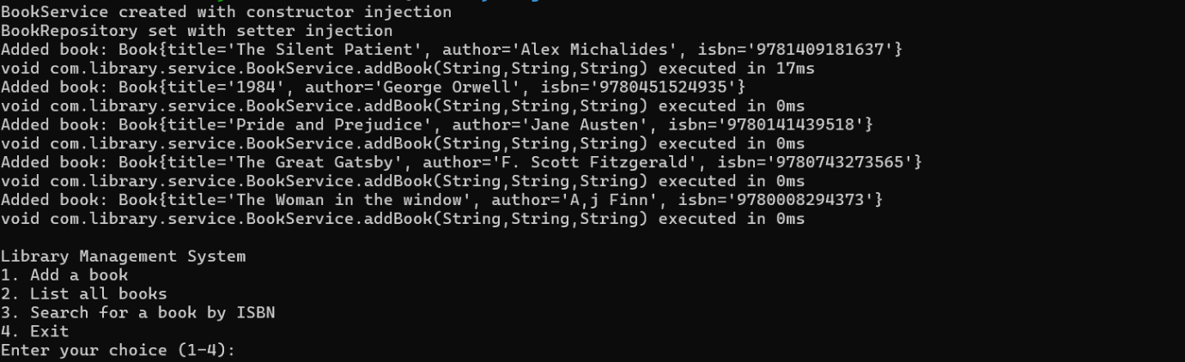output

**Exercise 4: Maven Project Configuration**

After completion:

* The pom.xml file is updated with necessary Spring dependencies.
* Maven plugins are configured for the project.

Observable changes:

* Simplified dependency management.
* Consistent build process across different development environments.
* Easier project sharing and collaboration among team members.

**Exercise 5: Spring IoC Container Configuration**

After completion:

* A comprehensive applicationContext.xml file defines all beans and their relationships.

Observable changes:

* Centralized configuration for all application components.
* Clear visibility of the application's structure and dependencies.
* Easier modification of application behavior without changing code.

**Exercise 6: Annotation-Based Bean Configuration**

After completion:

* XML configuration is reduced in favor of annotation-based configuration.
* Classes are annotated with @Service, @Repository, etc.

Observable changes:

* The program's behavior remains the same, demonstrating that annotation-based configuration works just as well as XML-based configuration.
* The BookService and BookRepository classes are now annotated with @Service and @Repository respectively, instead of being defined as beans in the XML file.
* Dependency injection is now handled by the @Autowired annotation in the BookService class, rather than being specified in the XML file.
* The applicationContext.xml file now includes <context:component-scan base-package="com.library"/> to enable component scanning, allowing Spring to automatically detect and register the annotated beans.
* The AOP aspects (LoggingAspect and SecurityAspect) are also annotated with @Component and @Aspect, allowing them to be automatically detected and applied

**Exercise 7: Constructor and Setter Injection**

After completion:

* Multiple ways of injecting dependencies are implemented.

Observable changes:

* The class is annotated with @Service, indicating that it's a service component to be automatically detected by Spring's component scanning.
* There are two injection methods:
  + Constructor injection: The constructor is annotated with @Autowired, allowing Spring to inject the BookRepository when creating the BookService bean.
  + Setter injection: The setBookRepository method is also annotated with @Autowired, providing an alternative way for Spring to inject the dependency.
* Both injection methods have print statements to demonstrate which one is being used.
* The core functionality (addBook, listBooks, findBookByIsbn) remains the same as in previous exercises.
* The @Autowired annotation on the constructor can be omitted if there's only one constructor, as Spring will use it by default. However, it's included here for clarity.

When you run the application, you'll see which injection method is being used based on the print statements. By default, if both are present, Spring typically prefers constructor injection.

This implementation demonstrates the flexibility of Spring's dependency injection, allowing for both constructor and setter injection in the same class. In a real-world scenario, you would typically choose one method over the other based on your specific requirements and coding standards.

**Exercise 8: Basic AOP Implementation**

After completion:

* Aspects are defined for cross-cutting concerns like logging and potentially transaction management.

Observable changes:

* Cleaner separation of concerns in the codebase.
* Ability to add or modify behavior across multiple parts of the application from a single location.
* Improved maintainability of cross-cutting functionalities.

**Exercise 9: Spring Boot Application Creation**

After completion:

* The application is converted to a Spring Boot project.
* REST endpoints are implemented for CRUD operations on books.
* Database integration is set up with Spring Data JPA.

Observable changes:

* Significantly reduced configuration code.
* Built-in application server (e.g., Tomcat) for easy deployment.
* RESTful API endpoints for interacting with the Library Management System.
* Database operations are simplified with JPA repositories.
* Improved developer productivity with Spring Boot's auto-configuration.

**Overall System Improvements**

1. Modular Architecture: The system now has a clear separation of concerns with distinct layers (controller, service, repository).
2. Dependency Management: Spring's IoC container efficiently manages object creation and dependencies.
3. Aspect-Oriented Programming: Cross-cutting concerns are centralized, improving maintainability.
4. Database Integration: JPA simplifies database operations, making data persistence more straightforward.
5. RESTful API: The system now exposes REST endpoints, allowing for easy integration with front-end applications or other services.
6. Simplified Configuration: Moving to Spring Boot has significantly reduced boilerplate code and configuration complexity.
7. Improved Testability: The loosely coupled design facilitates easier unit and integration testing.
8. Scalability: The modular design and use of Spring Boot make it easier to scale and extend the application in the future.
9. Production Readiness: Spring Boot's built-in features for metrics, health checks, and externalized configuration make the application more suitable for production deployment.

**Conclusion**

The Library Management System has evolved from a basic Spring application to a robust, modular, and feature-rich Spring Boot application. These improvements provide a solid foundation for further development and scaling of the system to meet more complex library management needs.